**PROJECT DELIVERABLE 2**

Baystate Banner

CS506

**Authors:**

Abdullah Albijadi, Audrey McMillion, Gordon Ng, Ji Zhang, Thachathum Amornkasemwong

Here are our update to deliverable 2 checklist:

1. We are now incorporating more of the demographic data, so that is our secondary batch of data.
2. We refined our earlier submission and now included mapped results into Boston’s ward precincts, a map for each race.
3. We explored the change in voter turnout by election year as the other key question, also mapped into Boston’s precincts. Specifically, we explored the change in voter turnout by City Council election year, found the top 20 precincts with the greatest change, and performed some preliminary demographic analysis on these precincts. Here we found that the 2013 CC had the highest voter turnout, and the top precincts with the greatest change seem to be concentrated mostly in the Allston/Commonwealth Ave. areas of Boston.
4. Limitations: We are currently missing Mayoral 2013 data, and we still need to find income data broken down by precinct.
5. PR is submitted

In the following pages, you’ll see maps under each dataset title. Each dataset represents an election, and each map is visualizing a different race compared to the election results.

Mayoral 2017 Elections

**Preliminary Race:**

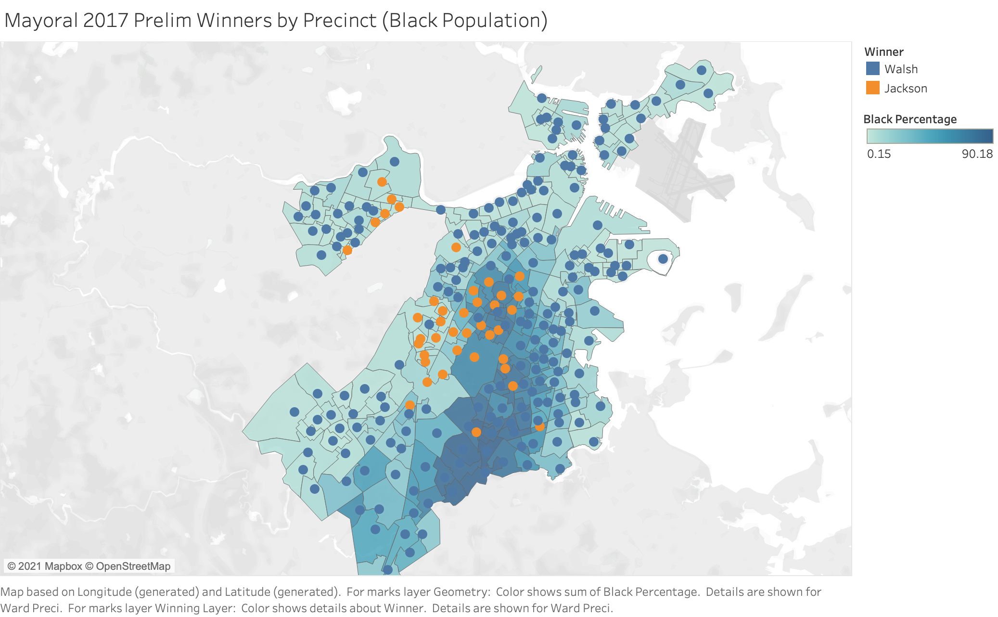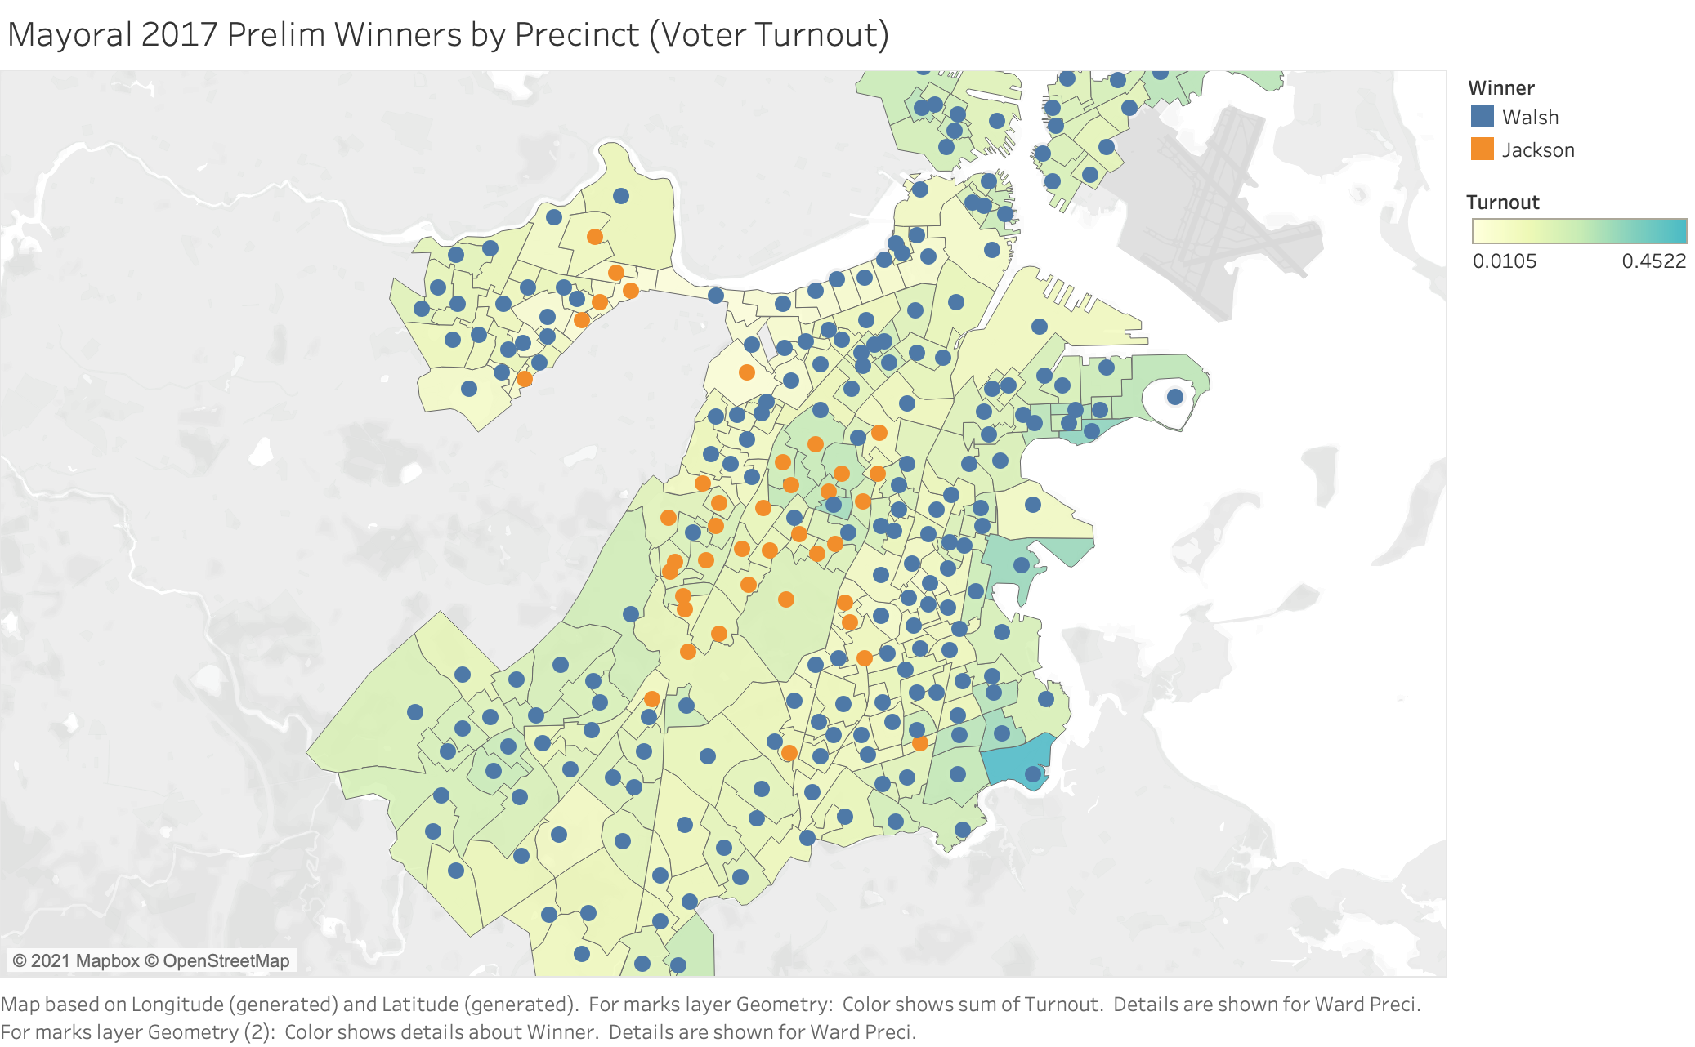

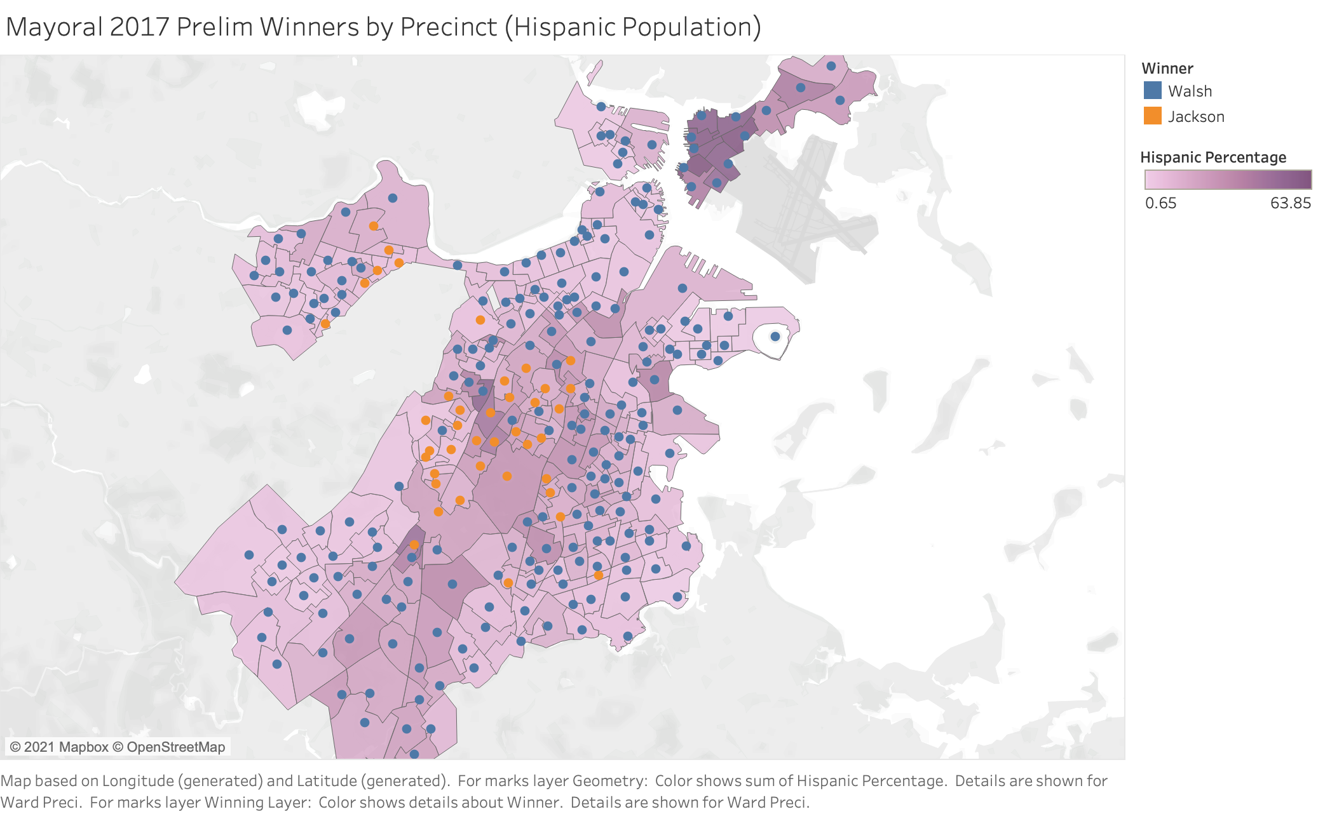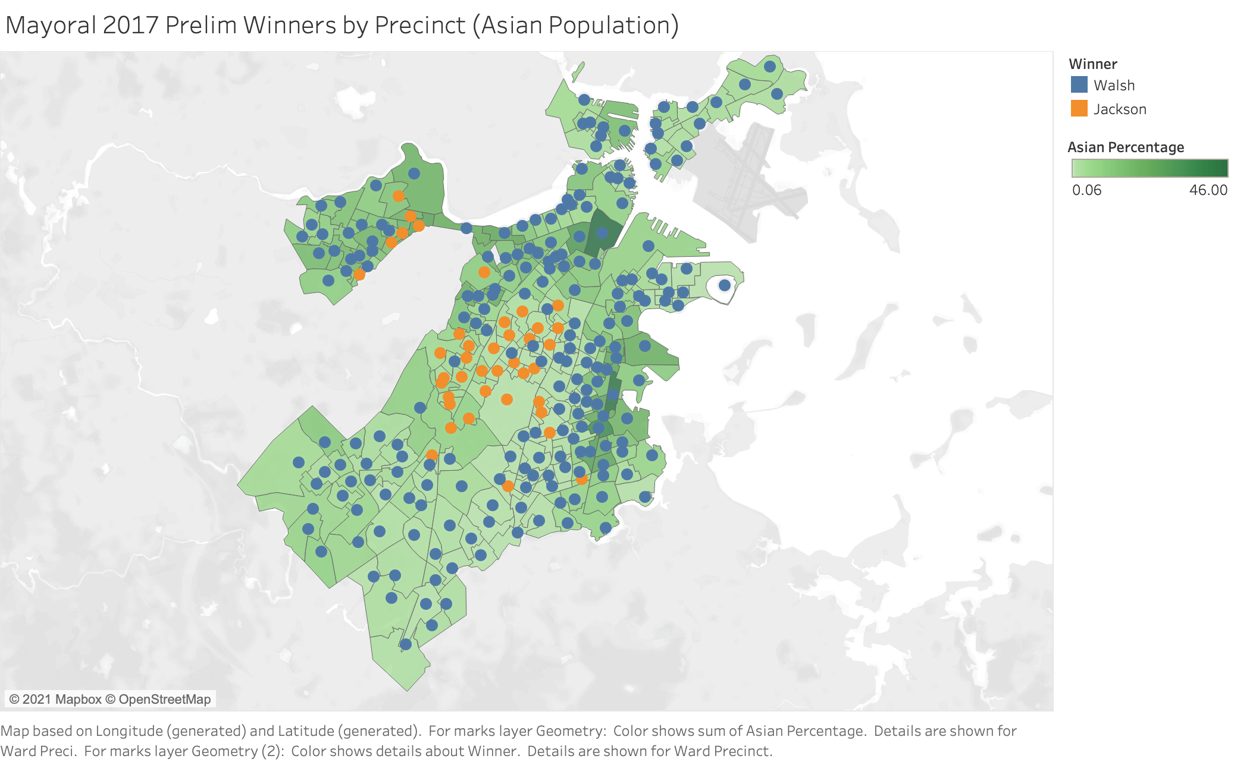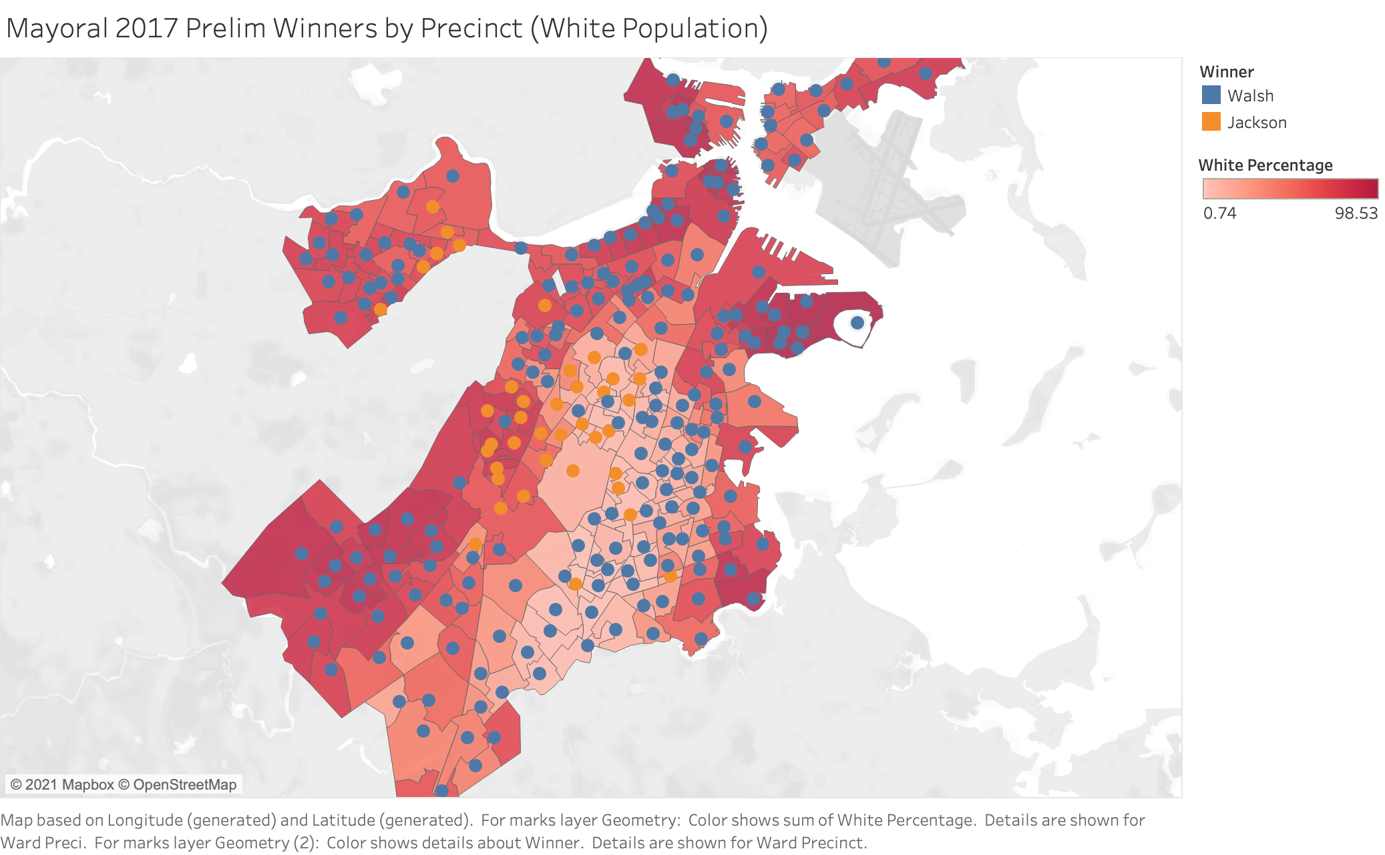

**General Race:**

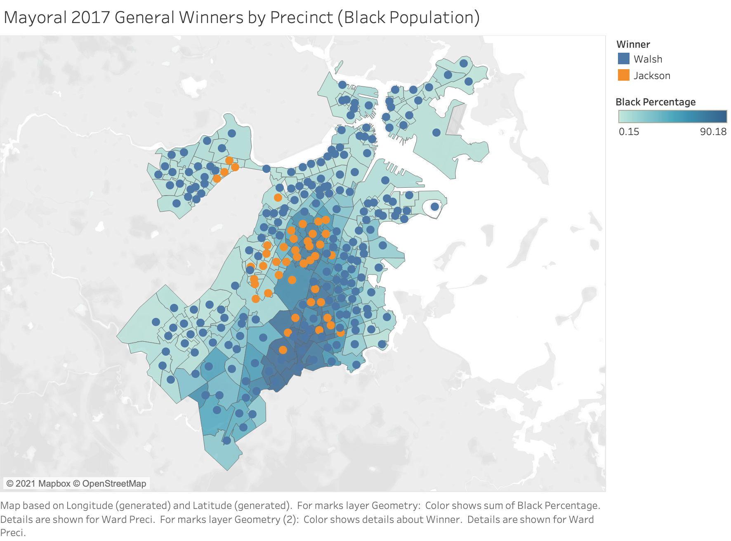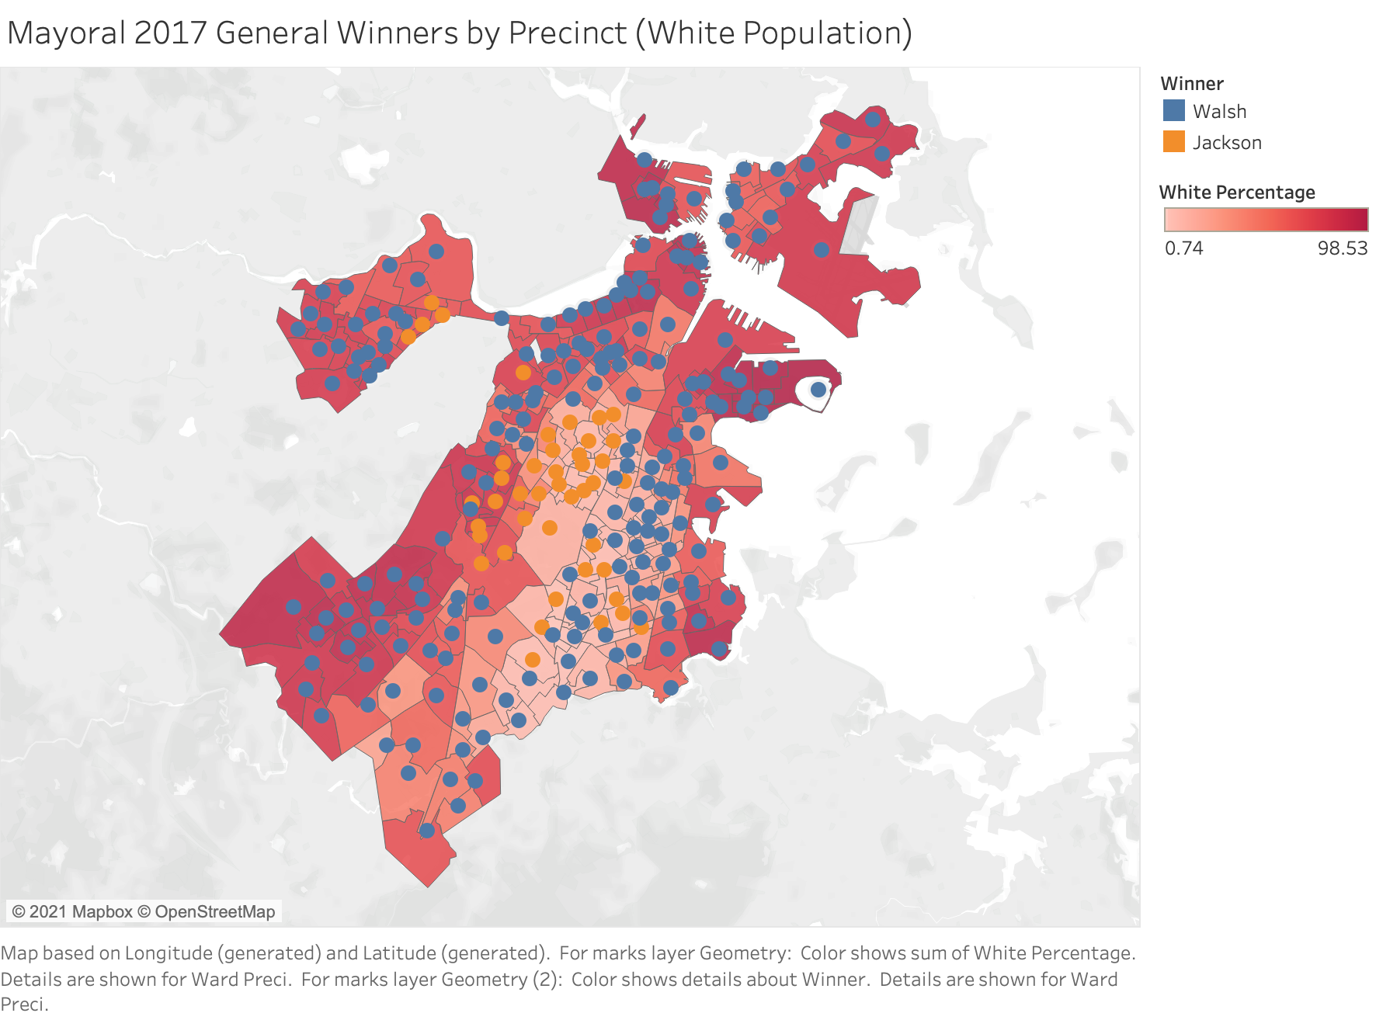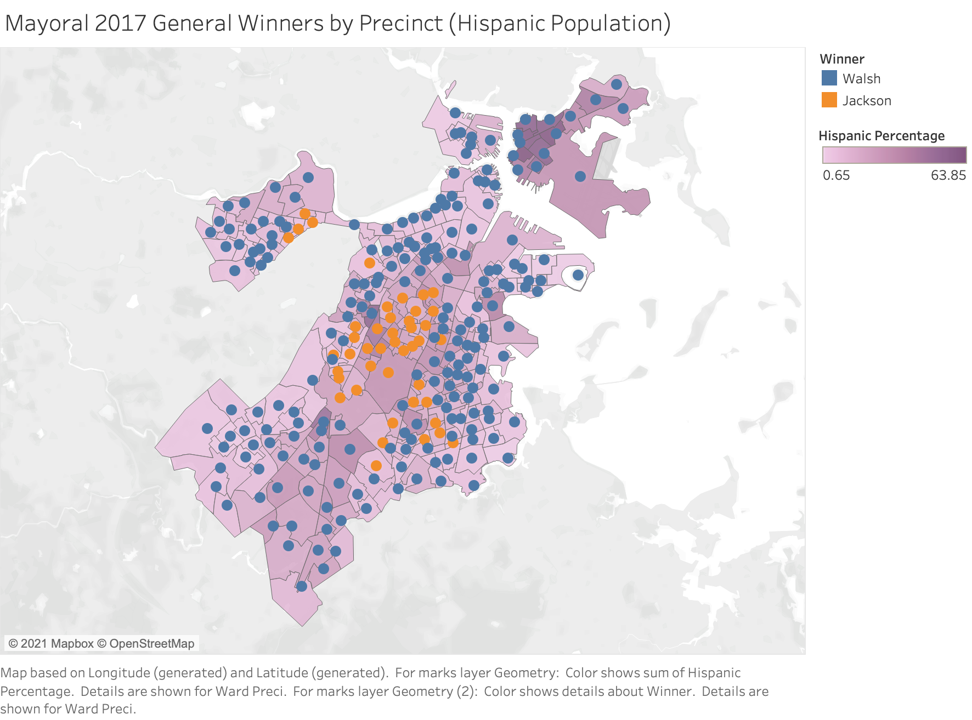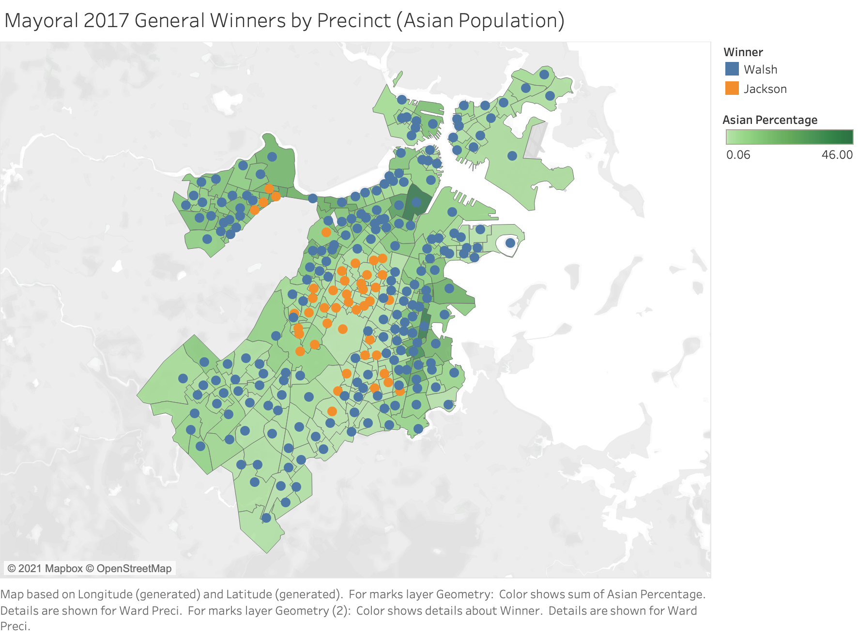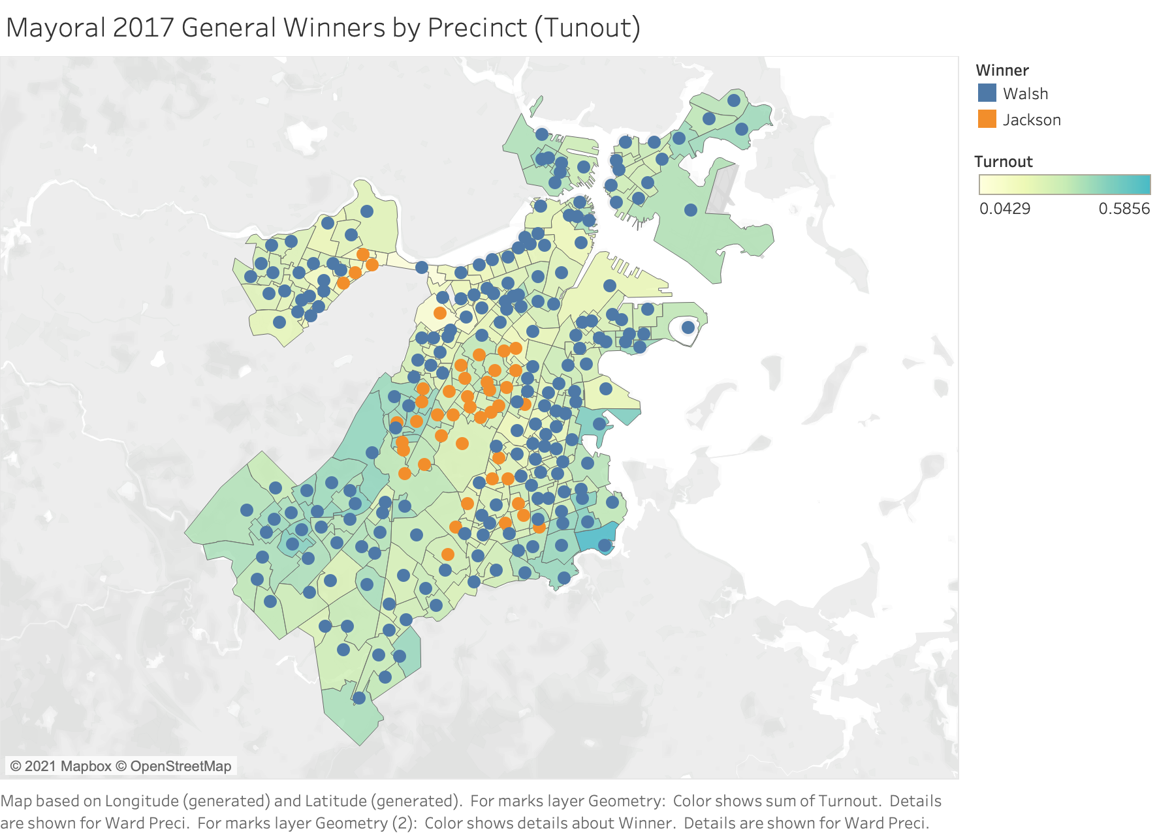

2019 City Council Analysis

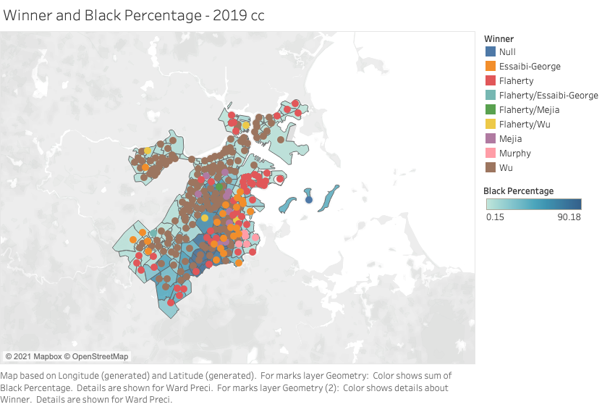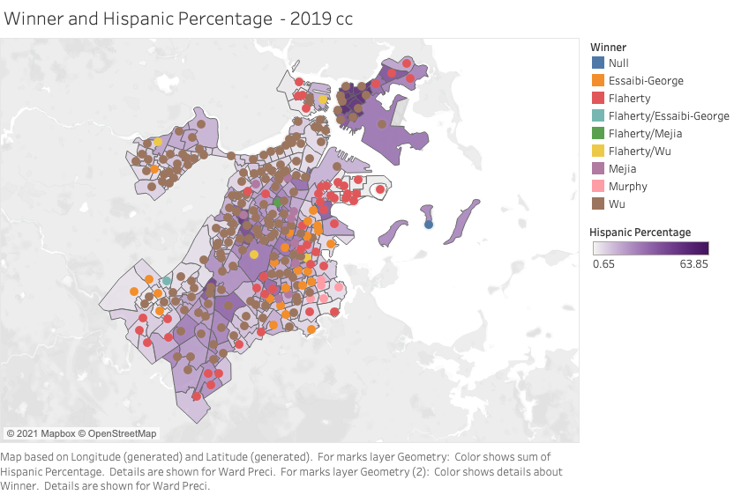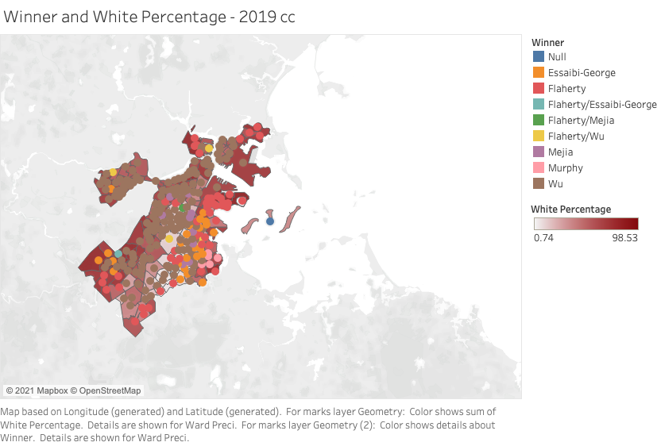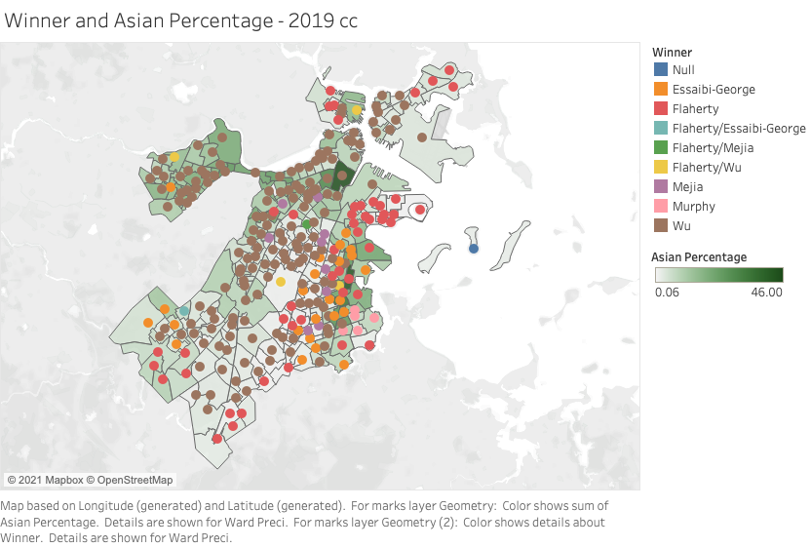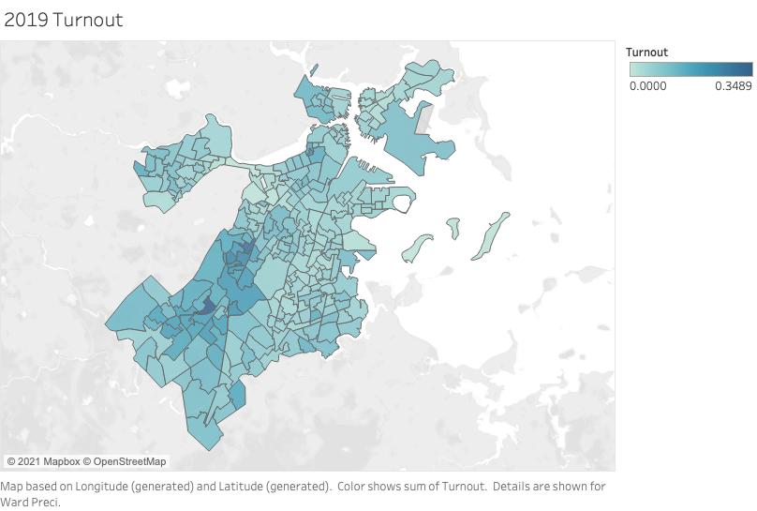

2017 City Council Analysis

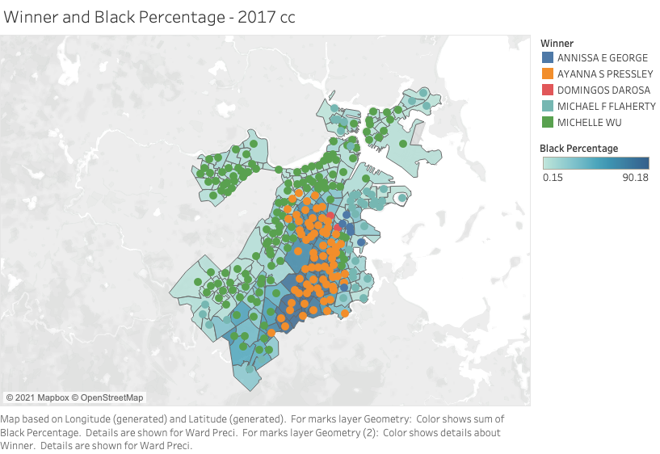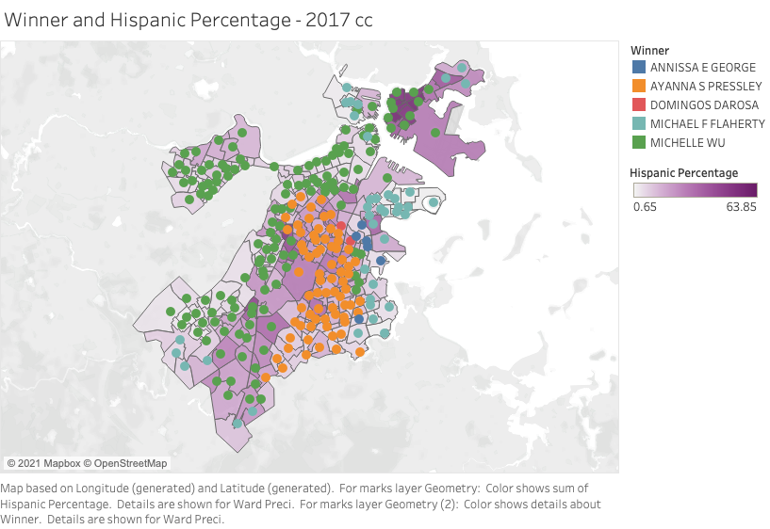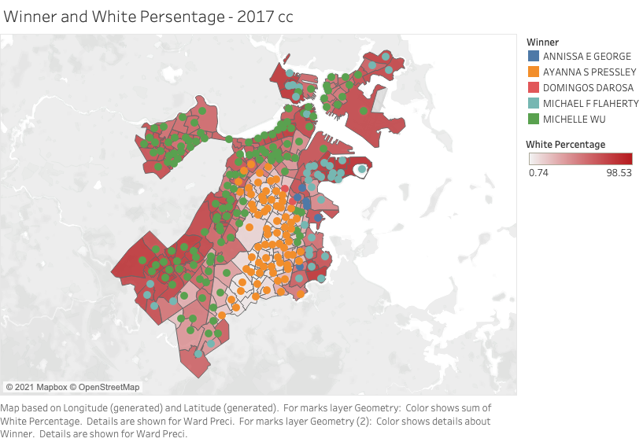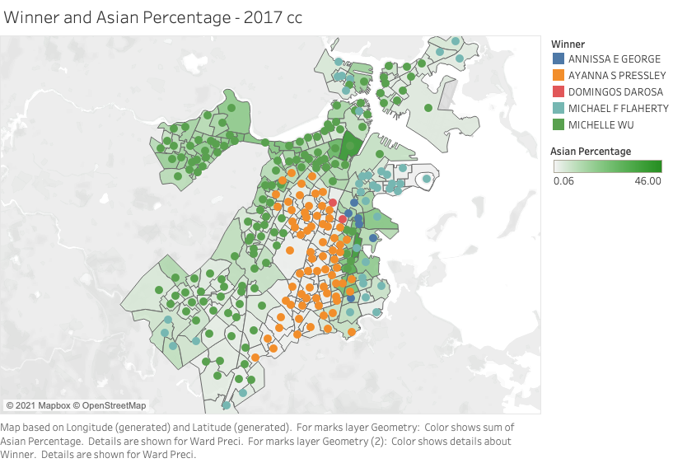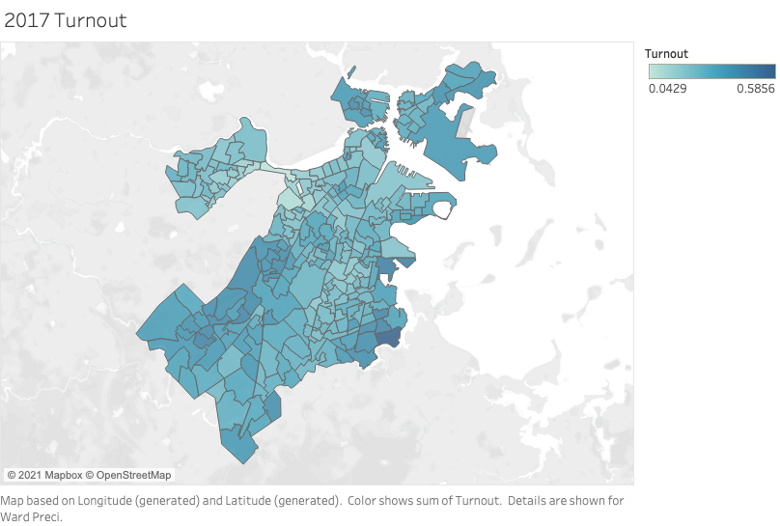

2015 City Council Analysis

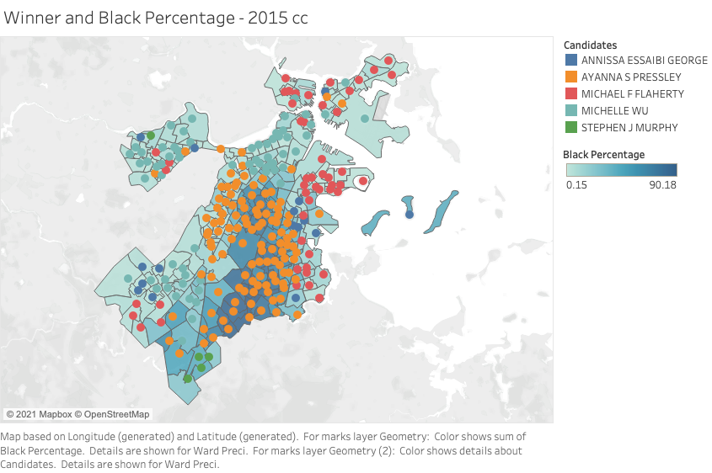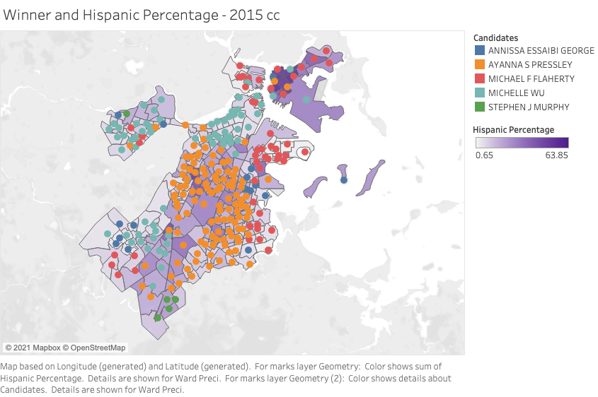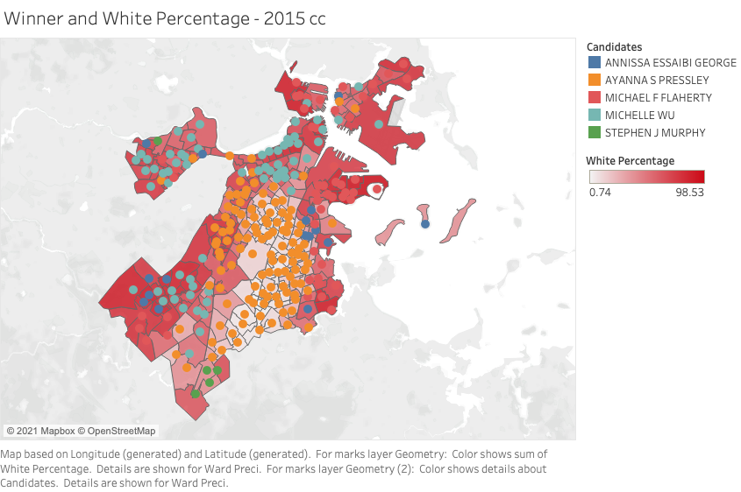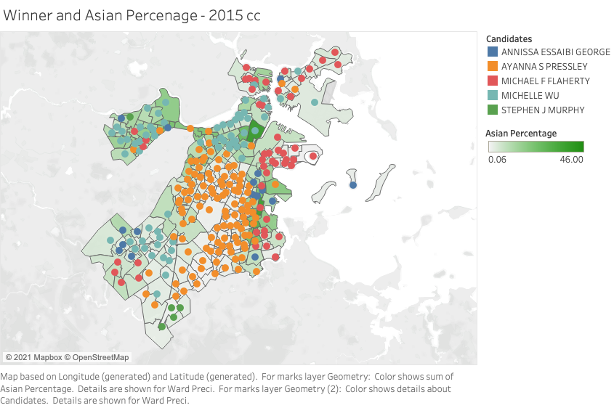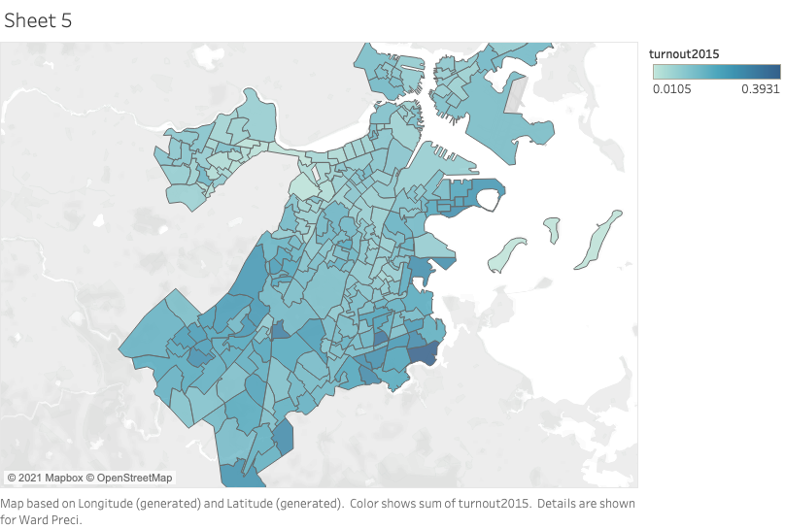

2013 City Council Analysis

Black Percentage & Candidates

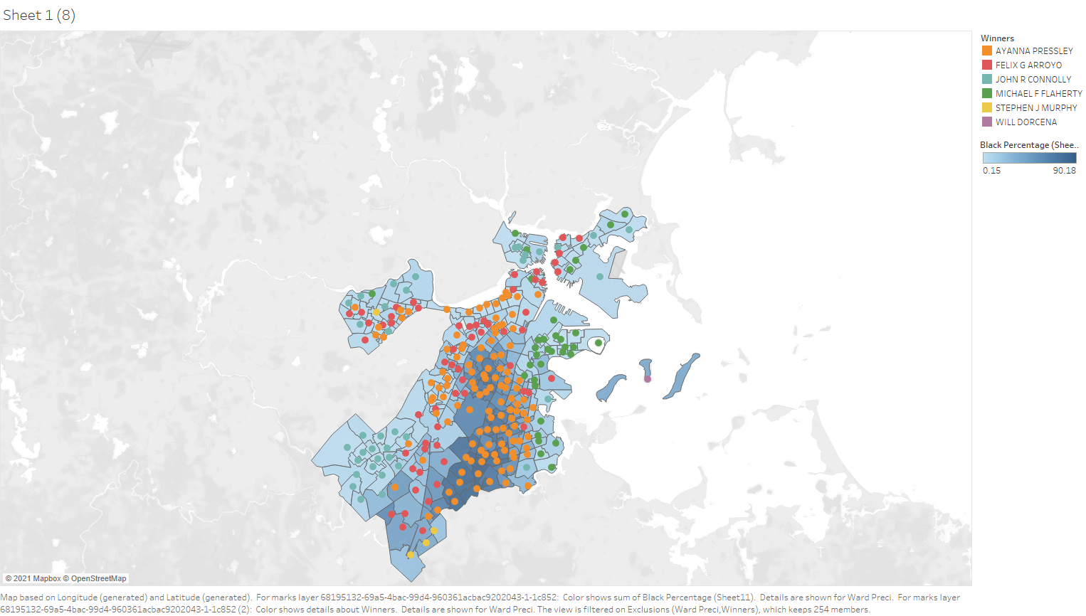

Hispanic Percentage & Candidates

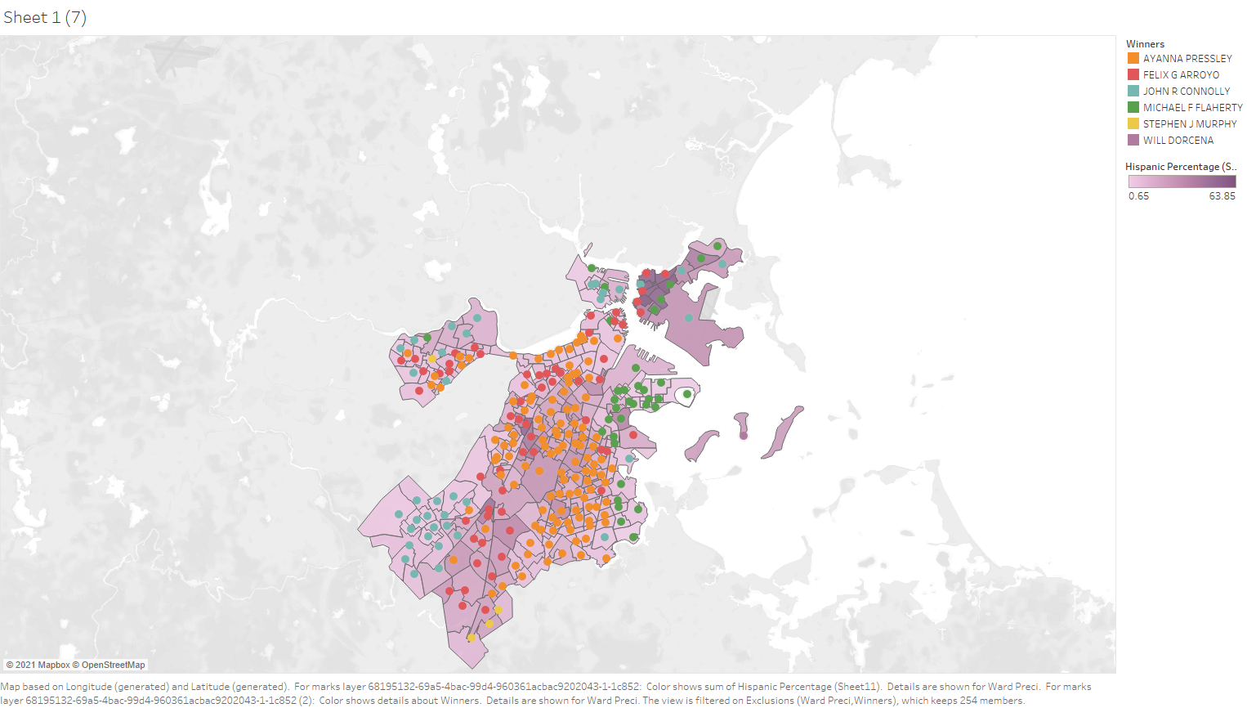

White Percentage & Candidates

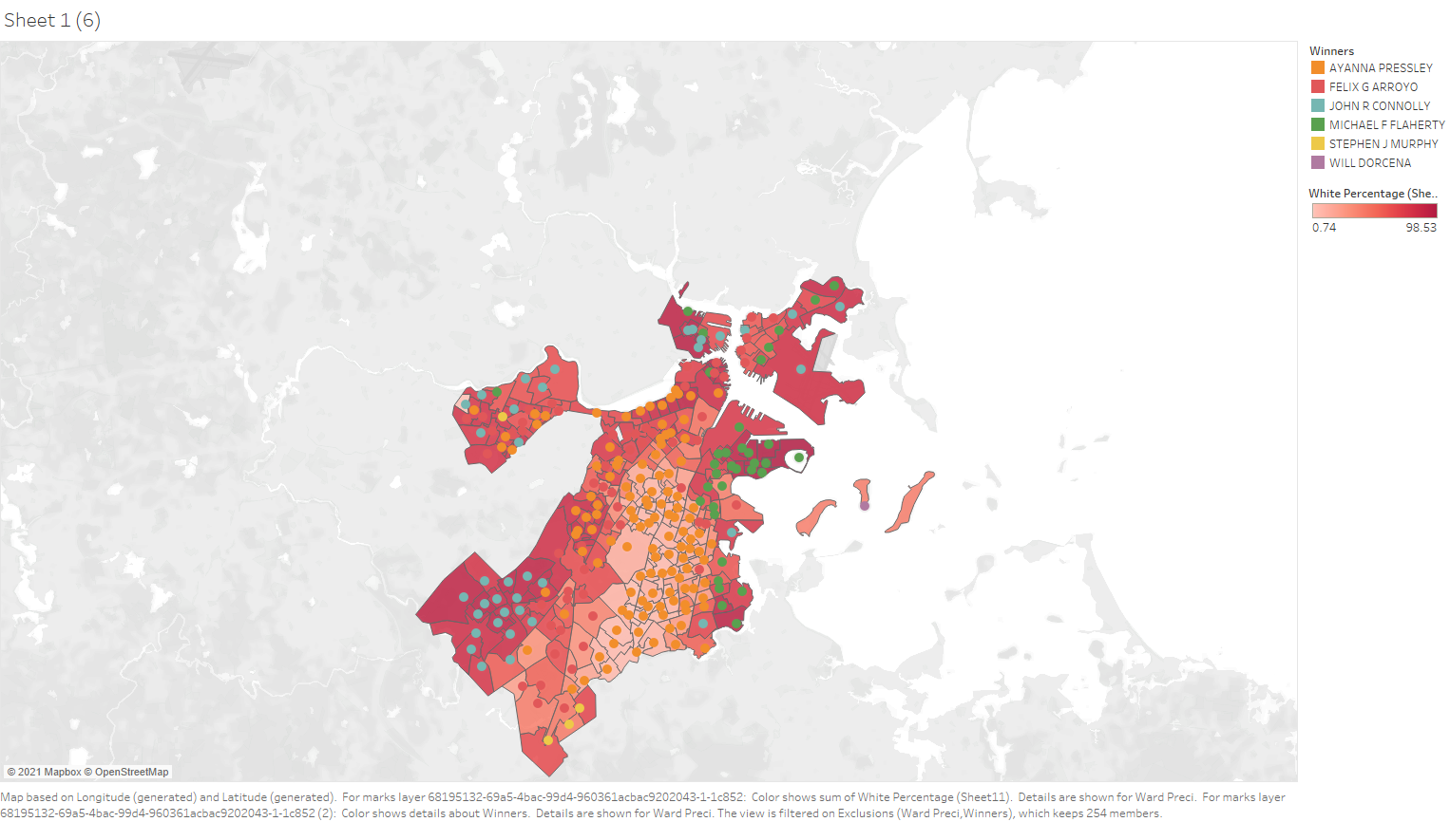

Asian Percentage & Candidates

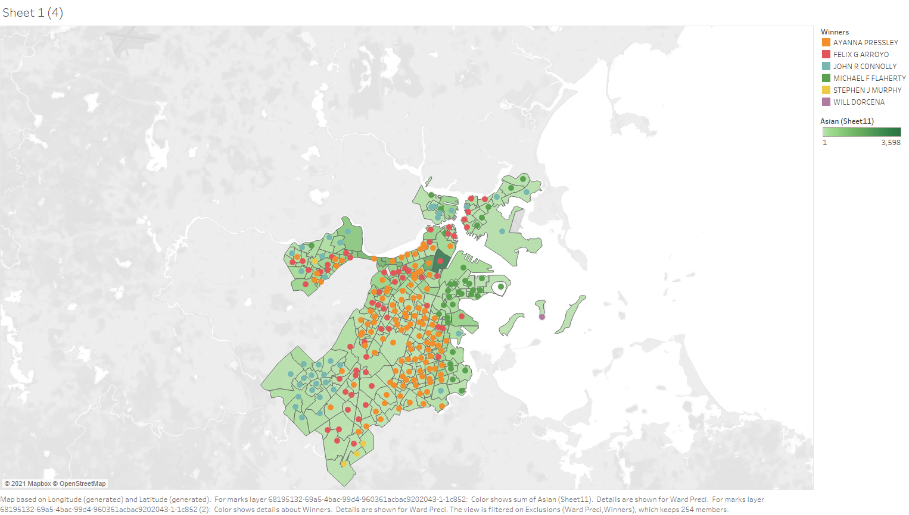

2011 City Council Analysis

Black Percentage & Candidates

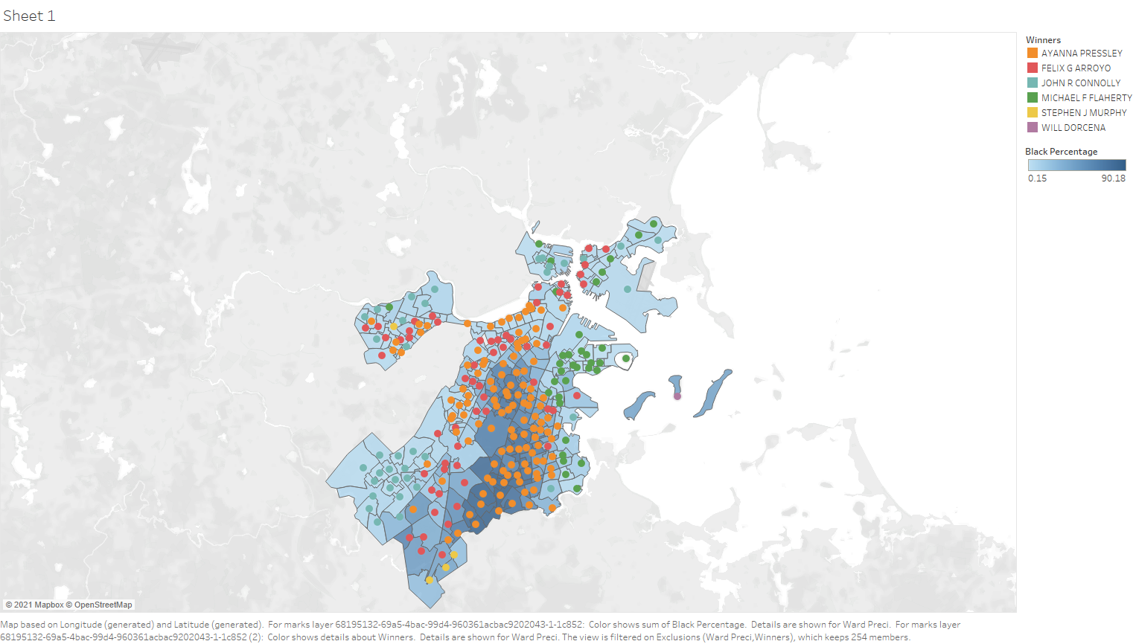

Hispanic Percentage & Candidates

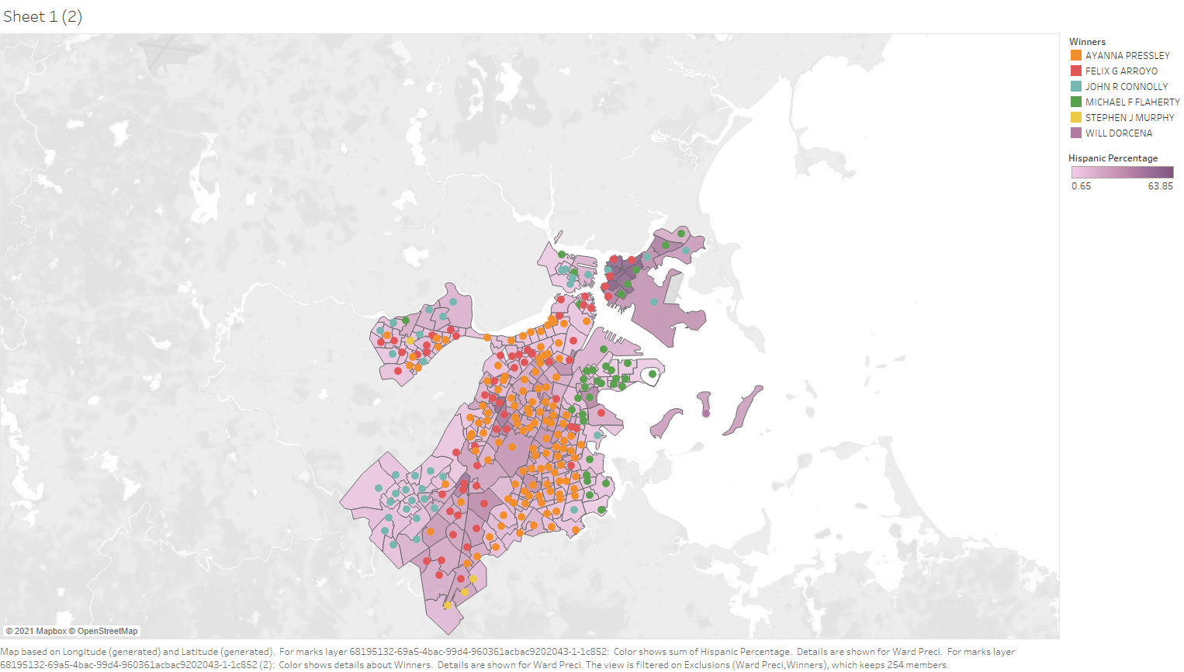

White Percentage & Candidates

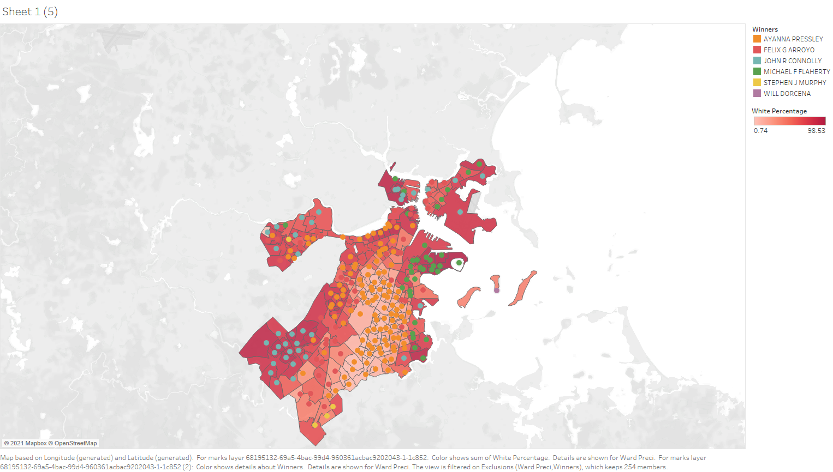

Asian Percentage & Candidates

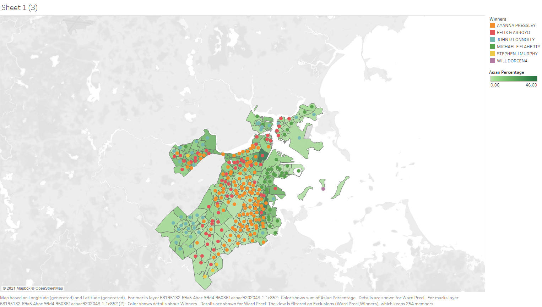

2020 US Senate Democratic Primary

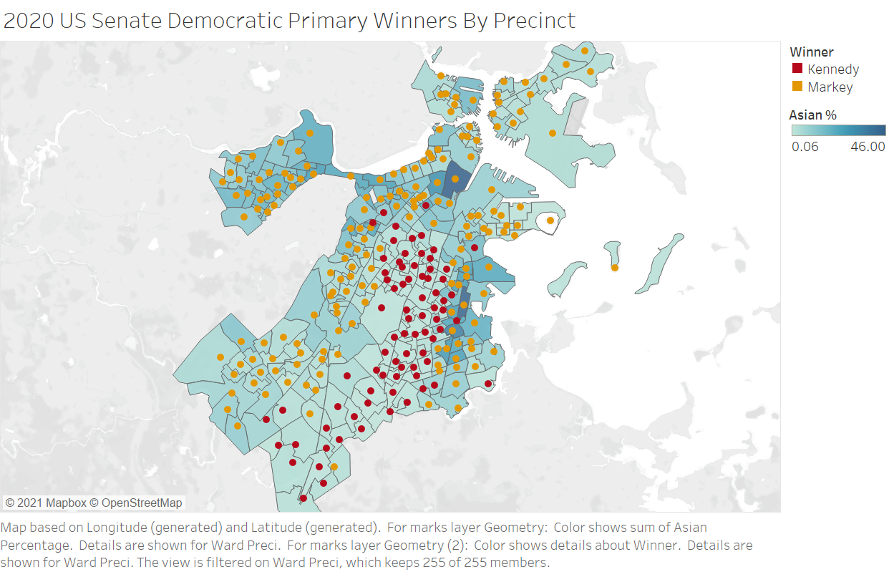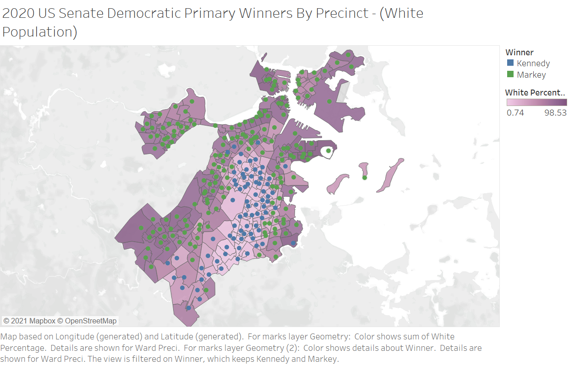

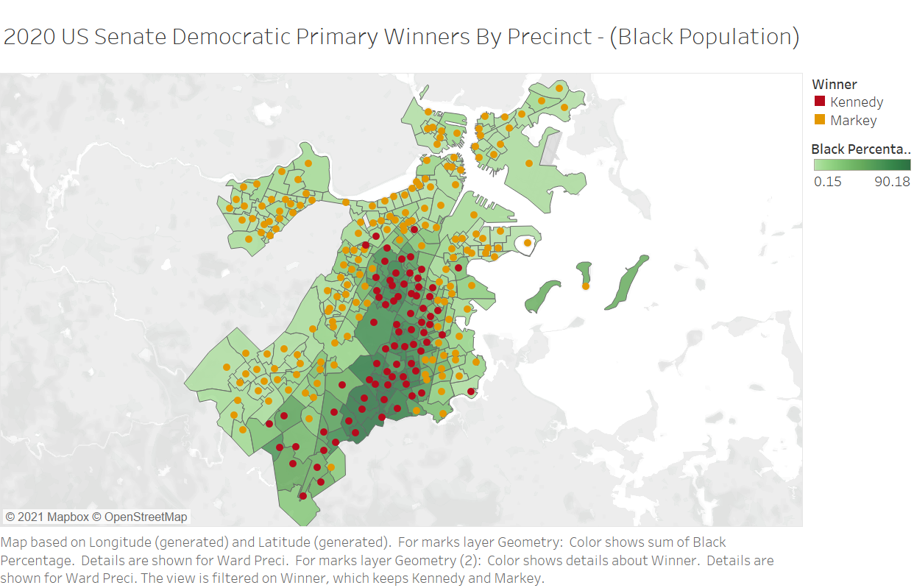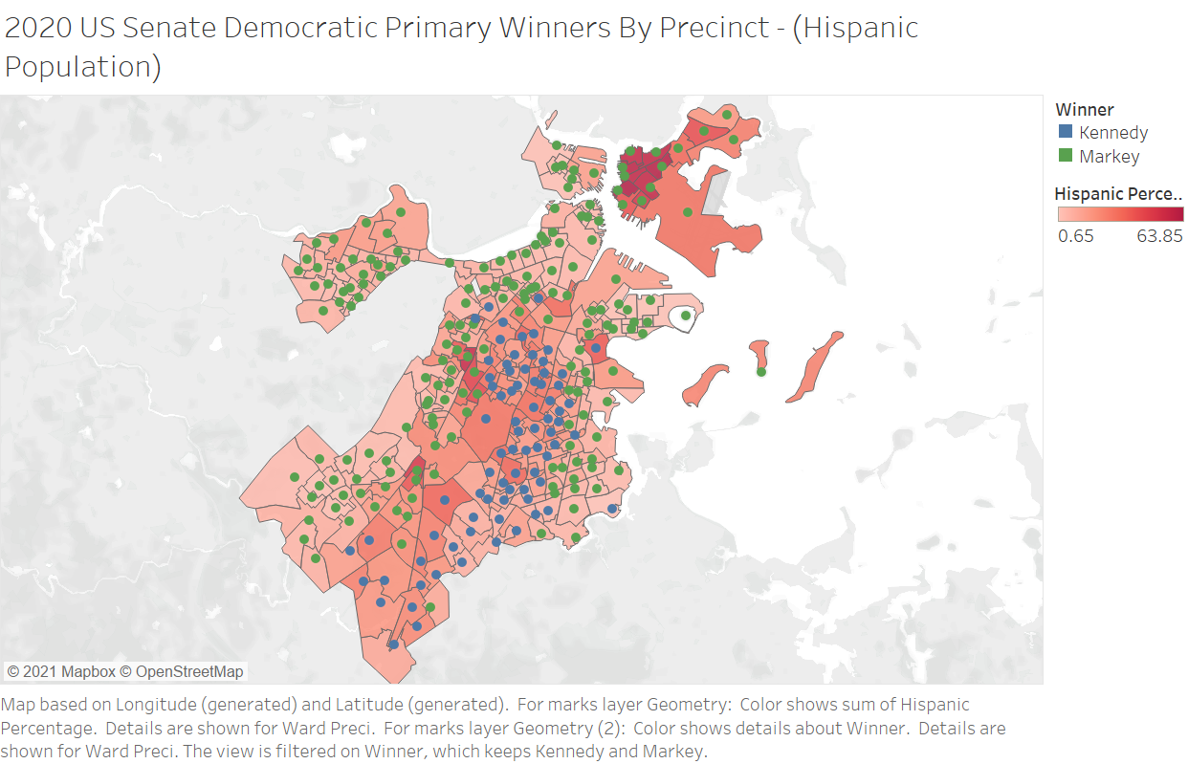

2018 US House Democratic Primary

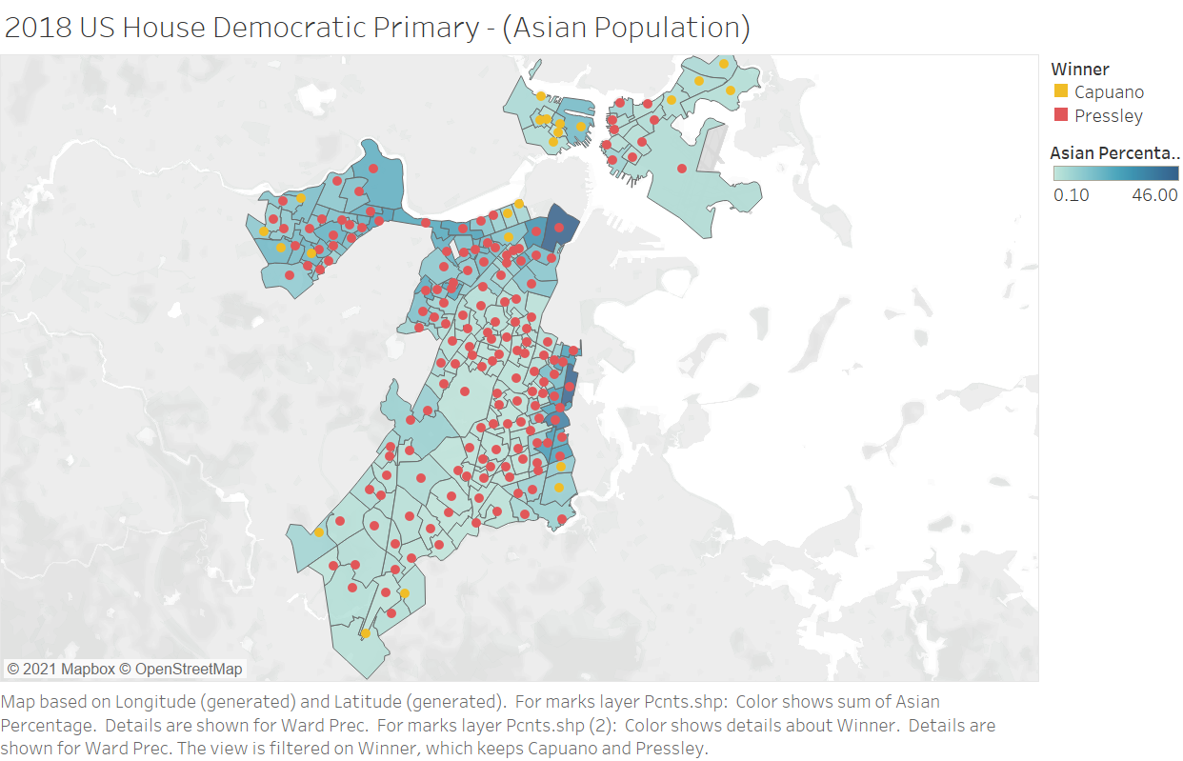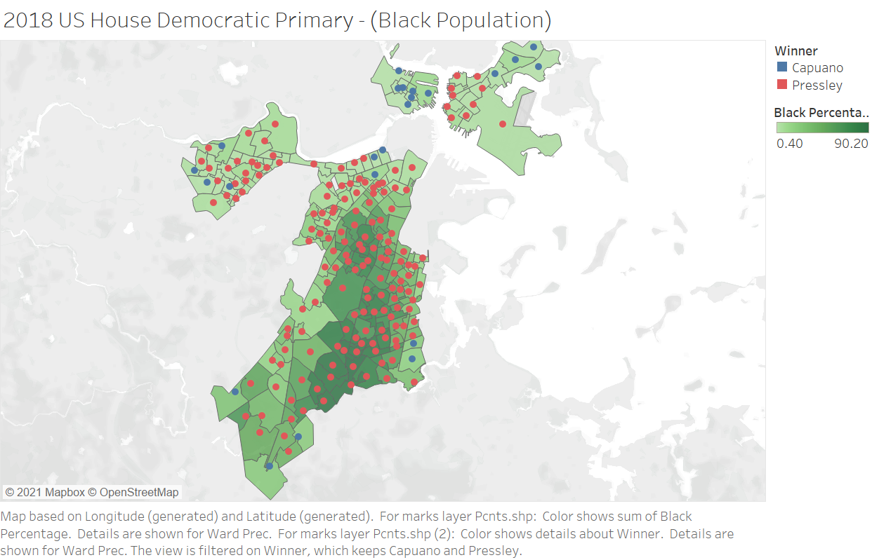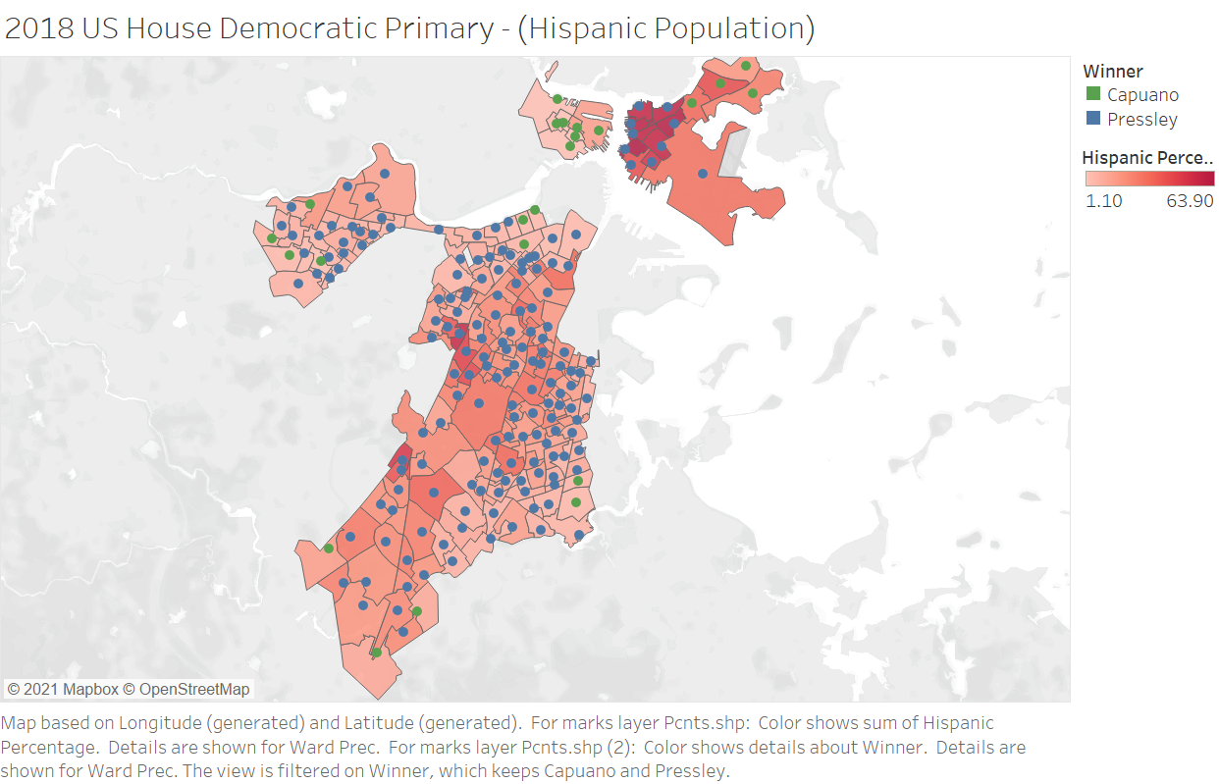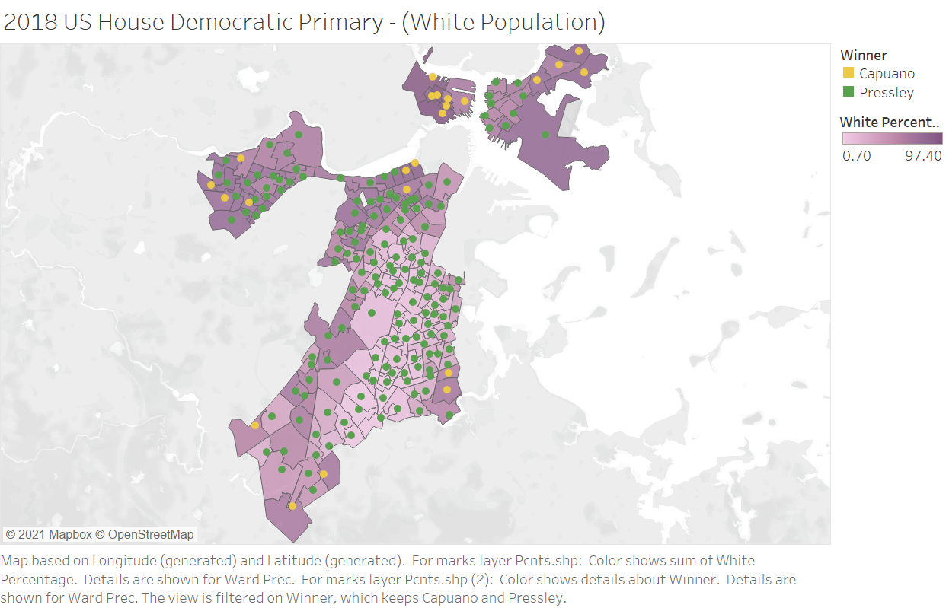

DA Race 2018

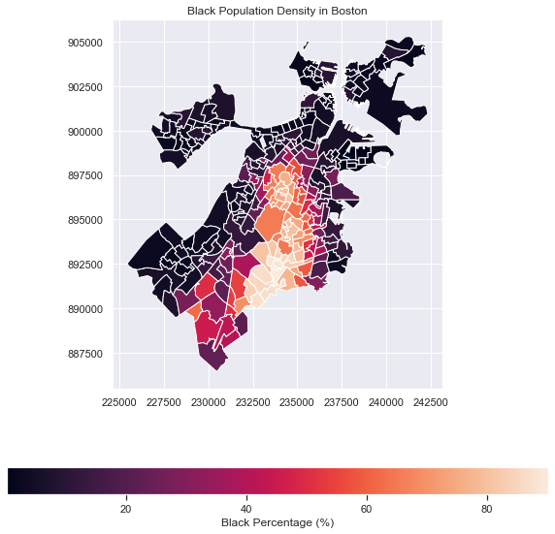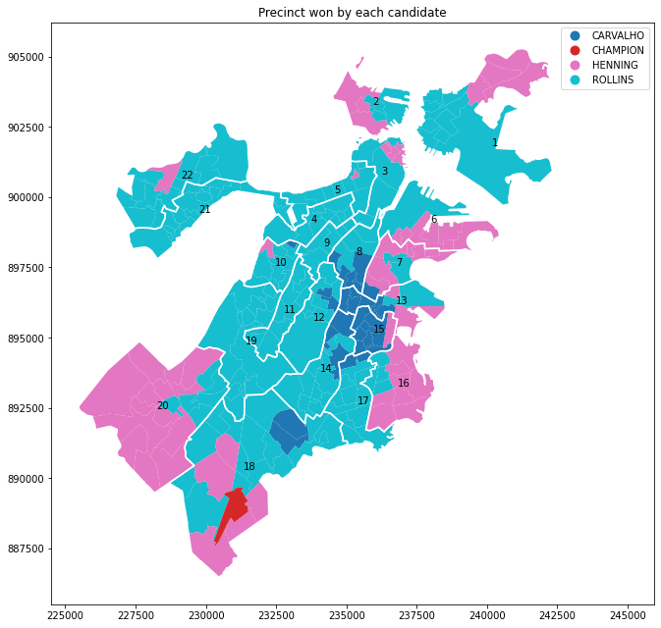

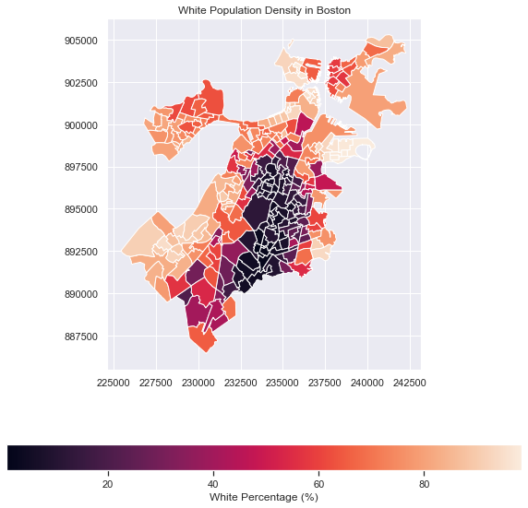

**For the City Council Turnout Analysis, we will be uploading a second document including all charts and analysis.**